Lab 7: SQL and PostGIS

In this lab we explored SQL and PostGIS on the ROGER super computer. We learned how to access a SQL database on ROGER. Many SQL operations were demonstrated including, creating and querying tables; adding and deleting entries; and finding statistical values such as ‘max’, ‘min’, ‘mean’ and ‘count’. Then we accessed PostGIS, created tables and performed queries and manipulations on the data set.

SQL:

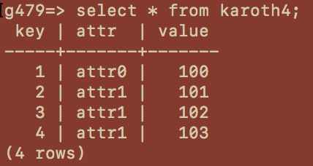

Fig 1: Query of all entries in the karoth4 table

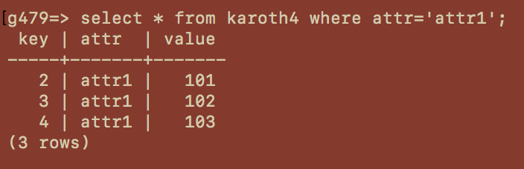

Fig 2: Conditional query of all entries with attr =’attr1’

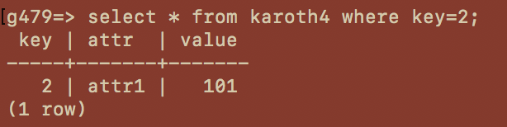

Fig 3: Conditional query of all entries with key=2

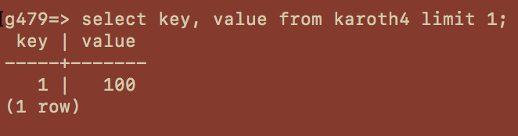

Fig 4: Select the first key value pair

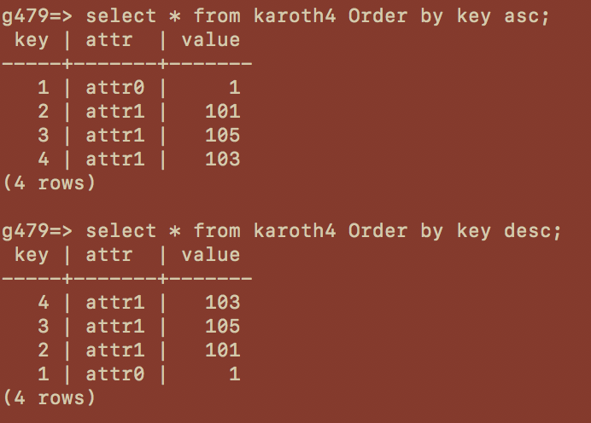

Fig 5: Display the table in ascending and descending order respectively

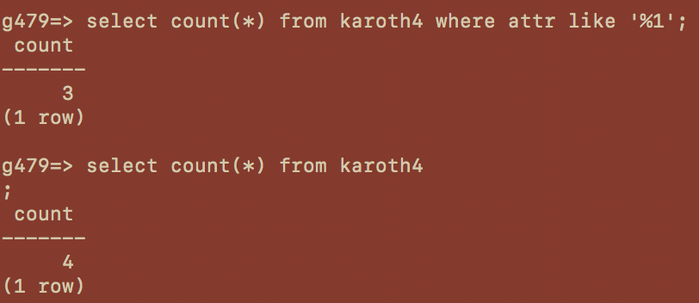

Fig 6: Count how many entries are in the table given certain conditions.

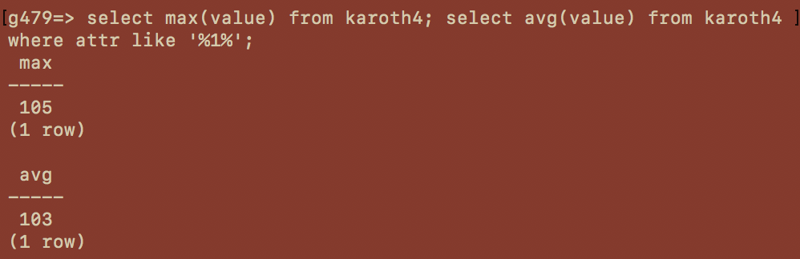

Fig 7: Find the maximum and average of “value”

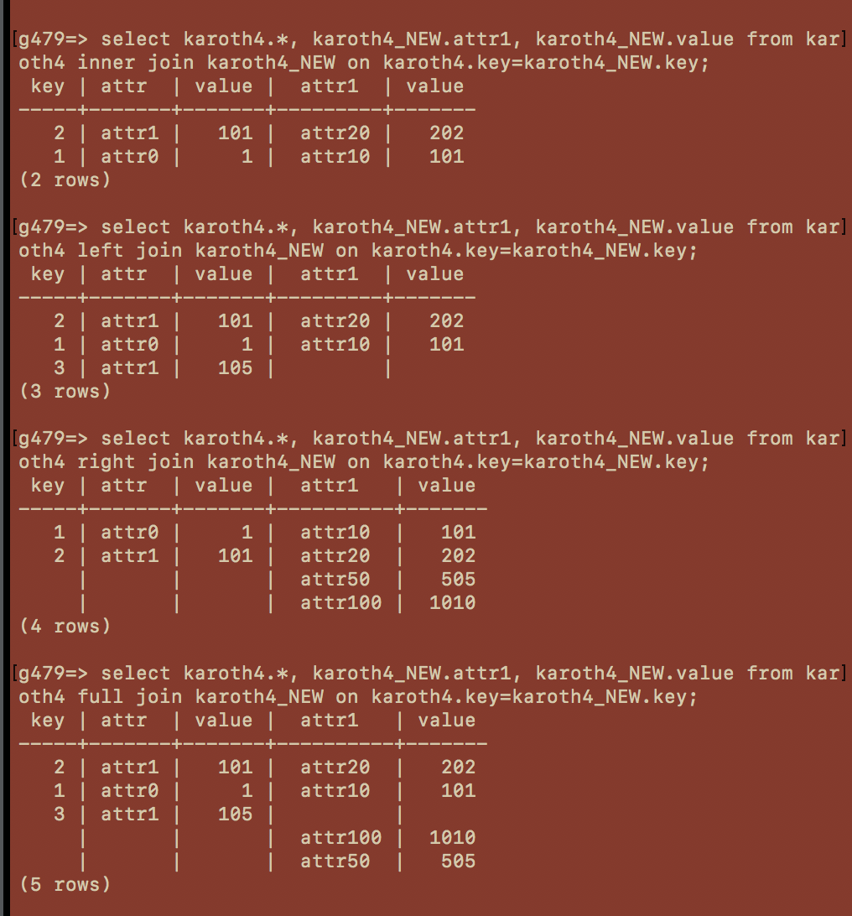

Fig 8: Examples of 4 different types of joins. The inner join only includes entries where all values are present. A left join includes entries where all of the first database values are present. Similarly, a right join includes all of the second tables values are present. And a full join joins all entries regardless of whether all the data values are present.

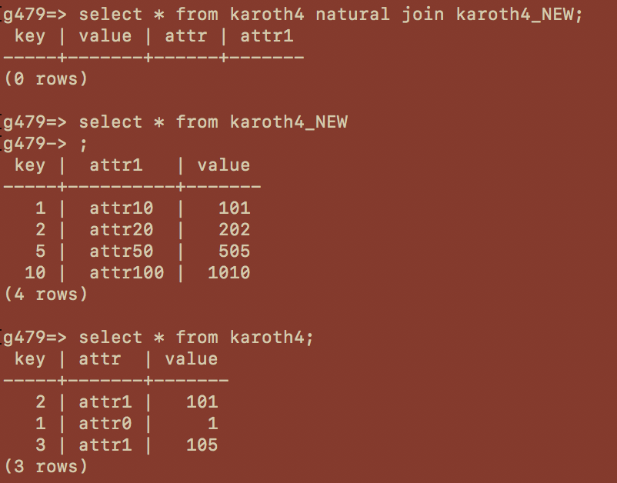

Fig 9: Demonstrates a natural join and the contents of the two tables that were joined in Fig 8 above.

PostGIS:

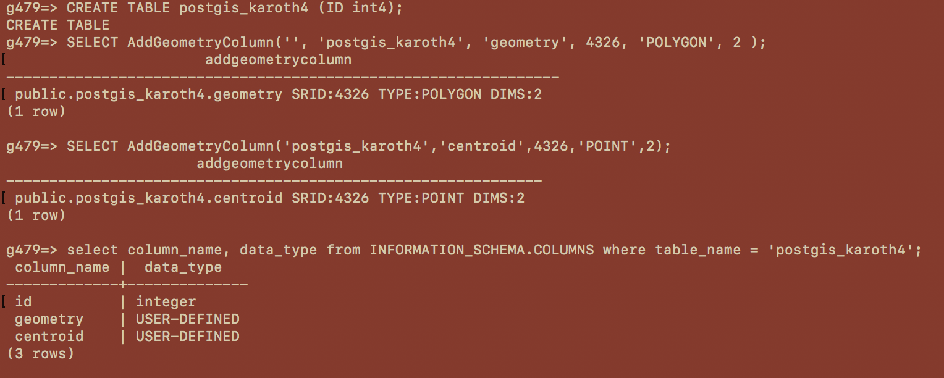

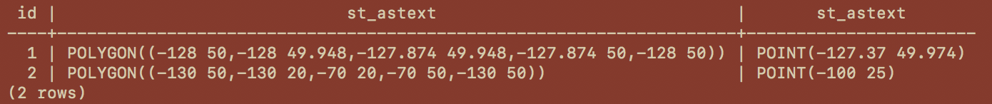Fig 10: Creation of the postGIS table, and a query of its contents

Fig 11: Different queries of the postgis_karoth4 tabl

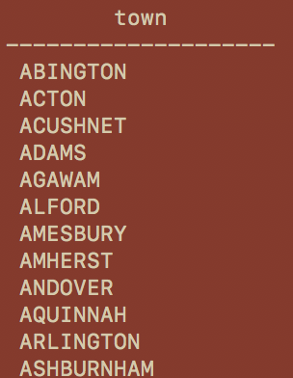

Fig 12: A list of all the towns in the towns table (concatenated in this figure)

The remainder of the functions were not able to be performed because when the query “town = ‘BOSTON’” was performed, there were zero entries. This made it impossible to do any other data manipulations. Various queries were attempted for other town names with the same results.